Git is a modern and widely used **distributed version control** system in the world. It is developed to manage projects with high speed and efficiency. The version control system allows us to monitor and work together with our team members at the same workspace.

What is Git?

**Git** is an **open-source distributed version control system**. It is designed to handle minor to major projects with high speed and efficiency. It is developed to co-ordinate the work among the developers. The version control allows us to track and work together with our team members at the same workspace.

Git is foundation of many services like **GitHub** and **GitLab**, but we can use Git without using any other Git services. Git can be used **privately** and **publicly**.

Git was created by **Linus Torvalds** in **2005** to develop Linux Kernel. It is also used as an important distributed version-control tool for **the DevOps**.

Git is easy to learn, and has fast performance. It is superior to other SCM tools like Subversion, CVS, Perforce, and ClearCase.

Features of Git

Some remarkable features of Git are as follows:

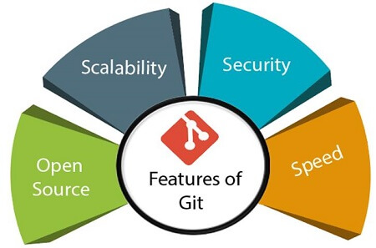

* **Open Source**  
  Git is an **open-source tool**. It is released under the **GPL** (General Public License) license.
* **Scalable**  
  Git is **scalable**, which means when the number of users increases, the Git can easily handle such situations.
* **Distributed**  
  One of Git's great features is that it is **distributed**. Distributed means that instead of switching the project to another machine, we can create a "clone" of the entire repository. Also, instead of just having one central repository that you send changes to, every user has their own repository that contains the entire commit history of the project. We do not need to connect to the remote repository; the change is just stored on our local repository. If necessary, we can push these changes to a remote repository.

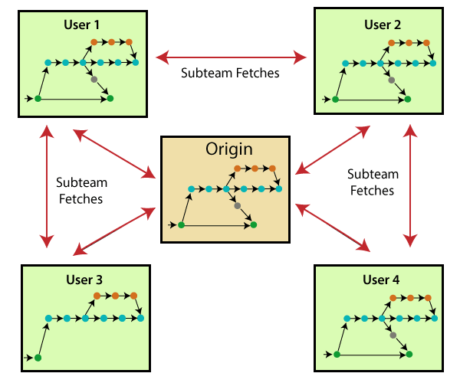

* **Security**  
  Git is secure. It uses the **SHA1 (Secure Hash Function)** to name and identify objects within its repository. Files and commits are checked and retrieved by its checksum at the time of checkout. It stores its history in such a way that the ID of particular commits depends upon the complete development history leading up to that commit. Once it is published, one cannot make changes to its old version.
* **Speed**  
  Git is very **fast**, so it can complete all the tasks in a while. Most of the git operations are done on the local repository, so it provides a **huge speed**. Also, a centralized version control system continually communicates with a server somewhere.  
  Performance tests conducted by Mozilla showed that it was **extremely fast compared to other VCSs**. Fetching version history from a locally stored repository is much faster than fetching it from the remote server. The **core part of Git**is **written in C**, which **ignores** runtime overheads associated with other high-level languages.  
  Git was developed to work on the Linux kernel; therefore, it is **capable** enough to **handle large** **repositories** effectively. From the beginning, **speed** and **performance** have been Git's primary goals.
* **Supports non-linear development**  
  Git supports **seamless branching and merging**, which helps in visualizing and navigating a non-linear development. A branch in Git represents a single commit. We can construct the full branch structure with the help of its parental commit.
* **Branching and Merging**  
  **Branching and merging** are the **great feature**s of Git, which makes it different from the other SCM tools. Git allows the **creation of multiple branches** without affecting each other. We can perform tasks like **creation**, **deletion**, and **merging** on branches, and these tasks take a few seconds only. Below are some features that can be achieved by branching:
  + We can **create a separate branch** for a new module of the project, commit and delete it whenever we want.
  + We can have a **production branch**, which always has what goes into production and can be merged for testing in the test branch.
  + We can create a **demo branch** for the experiment and check if it is working. We can also remove it if needed.
  + The core benefit of branching is if we want to push something to a remote repository, we do not have to push all of our branches. We can select a few of our branches, or all of them together.
* **Data Assurance**  
  The Git data model ensures the **cryptographic integrity** of every unit of our project. It provides a **unique commit ID** to every commit through a **SHA algorithm**. We can **retrieve** and **update** the commit by commit ID. Most of the centralized version control systems do not provide such integrity by default.
* **Staging Area**  
  The **Staging area** is also a **unique functionality** of Git. It can be considered as a **preview of our next commit**, moreover, an **intermediate area** where commits can be formatted and reviewed before completion. When you make a commit, Git takes changes that are in the staging area and make them as a new commit. We are allowed to add and remove changes from the staging area. The staging area can be considered as a place where Git stores the changes.  
  Although, Git doesn't have a dedicated staging directory where it can store some objects representing file changes (blobs). Instead of this, it uses a file called index.

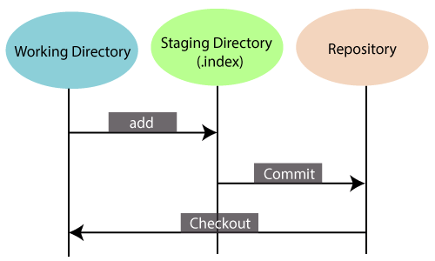

Another feature of Git that makes it apart from other SCM tools is that **it is possible to quickly stage some of our files and commit them without committing other modified files in our working directory.**

* **Maintain the clean history**  
  Git facilitates with Git Rebase; It is one of the most helpful features of Git. It fetches the latest commits from the master branch and puts our code on top of that. Thus, it maintains a clean history of the project.

Benefits of Git

A version control application allows us to **keep track** of all the changes that we make in the files of our project. Every time we make changes in files of an existing project, we can push those changes to a repository. Other developers are allowed to pull your changes from the repository and continue to work with the updates that you added to the project files.

Some **significant benefits** of using Git are as follows:

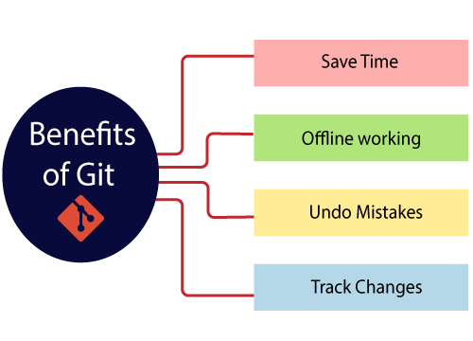

* **Saves Time**  
  Git is lightning fast technology. Each command takes only a few seconds to execute so we can save a lot of time as compared to login to a GitHub account and find out its features.
* **Offline Working**  
  One of the most important benefits of Git is that it supports **offline working**. If we are facing internet connectivity issues, it will not affect our work. In Git, we can do almost everything locally. Comparatively, other CVS like SVN is limited and prefer the connection with the central repository.
* **Undo Mistakes**  
  One additional benefit of Git is we can **Undo** mistakes. Sometimes the undo can be a savior option for us. Git provides the undo option for almost everything.
* **Track the Changes**  
  Git facilitates with some exciting features such as **Diff, Log,** and **Status**, which allows us to track changes so we can **check the status, compare** our files or branches.

Why Git?

We have discussed many **features** and **benefits** of Git that demonstrate the undoubtedly Git as the **leading version control system**. Now, we will discuss some other points about why should we choose Git.

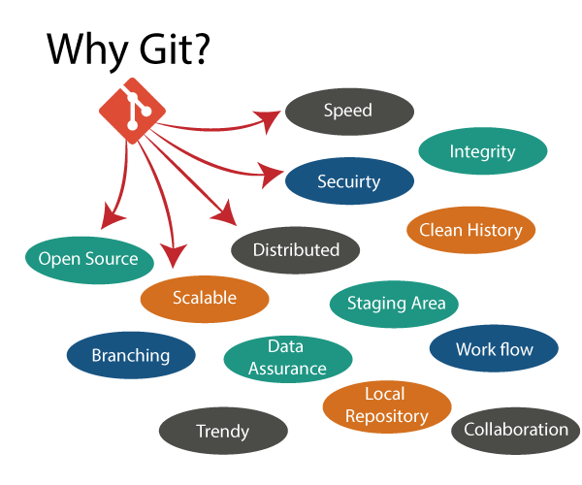

* **Git Integrity**  
  Git is **developed to ensure** the **security** and **integrity** of content being version controlled. It uses checksum during transit or tampering with the file system to confirm that information is not lost. Internally it creates a checksum value from the contents of the file and then verifies it when transmitting or storing data.
* **Trendy Version Control System**  
  Git is the **most widely used version control system**. It has **maximum projects** among all the version control systems. Due to its **amazing workflow** and features, it is a preferred choice of developers.
* **Everything is Local**  
  Almost All operations of Git can be performed locally; this is a significant reason for the use of Git. We will not have to ensure internet connectivity.
* **Collaborate to Public Projects**  
  There are many public projects available on the GitHub. We can collaborate on those projects and show our creativity to the world. Many developers are collaborating on public projects. The collaboration allows us to stand with experienced developers and learn a lot from them; thus, it takes our programming skills to the next level.
* **Impress Recruiters**  
  We can impress recruiters by mentioning the Git and GitHub on our resume. Send your GitHub profile link to the HR of the organization you want to join. Show your skills and influence them through your work. It increases the chances of getting hired.

# **What is GitHub?**

GitHub is a Git repository hosting service. GitHub also facilitates with many of its features, such as access control and collaboration. It provides a Web-based graphical interface.

GitHub is an American company. It hosts source code of your project in the form of different programming languages and keeps track of the various changes made by programmers.

It offers both **distributed version control and source code management (SCM)** functionality of Git. It also facilitates with some collaboration features such as bug tracking, feature requests, task management for every project.

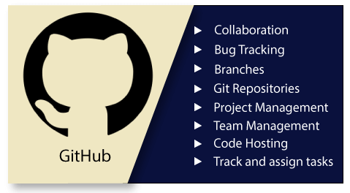

## Features of GitHub

GitHub is a place where programmers and designers work together. They collaborate, contribute, and fix bugs together. It hosts plenty of open source projects and codes of various programming languages.

Some of its significant features are as follows.

* Collaboration
* Integrated issue and bug tracking
* Graphical representation of branches
* Git repositories hosting
* Project management
* Team management
* Code hosting
* Track and assign tasks
* Conversations
* Wikisc

## Benefits of GitHub

GitHub can be separated as the Git and the Hub. GitHub service includes access controls as well as collaboration features like task management, repository hosting, and team management.

The key benefits of GitHub are as follows.

* It is easy to contribute to open source projects via GitHub.
* It helps to create an excellent document.
* You can attract recruiter by showing off your work. If you have a profile on GitHub, you will have a higher chance of being recruited.
* It allows your work to get out there in front of the public.
* You can track changes in your code across versions.

# **Difference between git and gitHub**

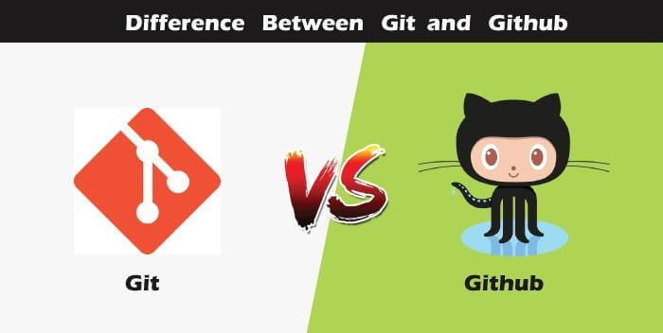

So, someone looking at git and github would find any apparent connection between them. Let us see git and github in detail with the differences between them.

## Git

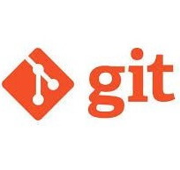

There are many words to define git, but it is an open-source distributed version control system in simpler words.

Let us break each component in the definition and understand it.

* **Open-source -** A type of computer software released under a specific license. The users are given permissions to use the code, modify the code, give suggestions, clone the code to add new functionality. In other words, if the software is open-source, it is developed collaboratively in a public manner. The open-source softwares is cheaper, more flexible, and lasts longer than an authority or a company. The products in the source code include code, documents, formats for the users to understand and contribute to it. Using open-source a project can be expanded to update or revise the current features. Unix and Linux are examples of open-source softwares.
* **Control system -** The work of a control system is to track the content. In other words, git is used to storing the content to provide the services and features to the user.
* **Version Control system -** Just like an app has different updates due to bugs and additional feature addition, version changes, git also supports this feature. Many developers can add their code in parallel. So the version control system easily manages all the updates that are done previously.  
  Git provides the feature of branching in which the updated code can be done, and then it can be merged with the main branch to make it available to the users. It not only makes everything organized but keeps synchronization among the developers to avoid any mishap. Other examples of version control systems are Helix core, Microsoft TFS, etc.
* **Distributed version control system -** Here distributed version control system means if a developer contributes to open source, the code will also be available in his remote repository. The developer changes his local repository and then creates a pull request to merge his changes in the central repository. Hence, the word distributed means the code is stored in the central server and stored in every developer's remote system.

**Why is git needed?**

When a team works on real-life projects, git helps ensure no code conflicts between the developers. Furthermore, the project requirements change often. So a git manages all the versions. If needed, we can also go back to the original code. The concept of branching allows several projects to run in the same codebase.

## GitHub



By the name, we can visualize that it is a Hub, projects, communities, etc. GitHub is a Git repository hosting service that provides a web-based graphical interface. It is the largest community in the world. Whenever a project is open-source, that particular repository gains exposure to the public and invites several people to contribute.

The source code of several projects is available on github which developers can use in any means.

Using github, many developers can work on a single project remotely because it facilitates collaboration.

**Features of gitHub**

* Using github the project managers can collaborate, review and guide the developers regarding any changes. This makes project management easy.
* The github repositories can be made public or private. Thus allowing safety to an organization in case of a project.
* GitHub has a feature of pull requests and issues in which all the developers can stay on the same page and organize.
* All the codes and their documentation are in one place in the same repository. Hence it makes easy code hosting.
* There are some special tools that github uses to identify the vulnerabilities in the code which other softwares do not have. Hence there is safety among the developers from code start till launch.
* Github is available for mobile and desktops. The UI is so user-friendly that it becomes straightforward to get comfortable with and use it.

# **Git Version Control System**

A version control system is a software that tracks changes to a file or set of files over time so that you can recall specific versions later. It also allows you to work together with other programmers.

The version control system is a collection of software tools that help a team to manage changes in a source code. It uses a special kind of database to keep track of every modification to the code.

Developers can compare earlier versions of the code with an older version to fix the mistakes.

## Benefits of the Version Control System

The Version Control System is very helpful and beneficial in software development; developing software without using version control is unsafe. It provides backups for uncertainty. Version control systems offer a speedy interface to developers. It also allows software teams to preserve efficiency and agility according to the team scales to include more developers.

Some key benefits of having a version control system are as follows.

* Complete change history of the file
* Simultaneously working
* Branching and merging
* Traceability

## Types of Version Control System

* Localized version Control System
* Centralized version control systems
* Distributed version control systems

### **Localized Version Control Systems**

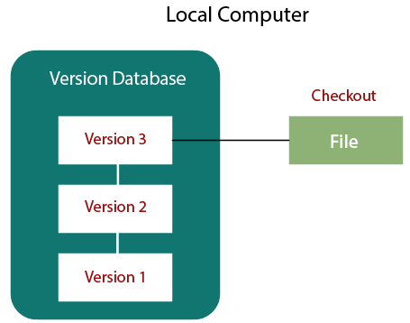

The localized version control method is a common approach because of its simplicity. But this approach leads to a higher chance of error. In this approach, you may forget which directory you're in and accidentally write to the wrong file or copy over files you don't want to.

To deal with this issue, programmers developed local VCSs that had a simple database. Such databases kept all the changes to files under revision control. A local version control system keeps local copies of the files.

The major drawback of Local VCS is that it has a single point of failure.

### **Centralized Version Control System**

The developers needed to collaborate with other developers on other systems. The localized version control system failed in this case. To deal with this problem, Centralized Version Control Systems were developed.

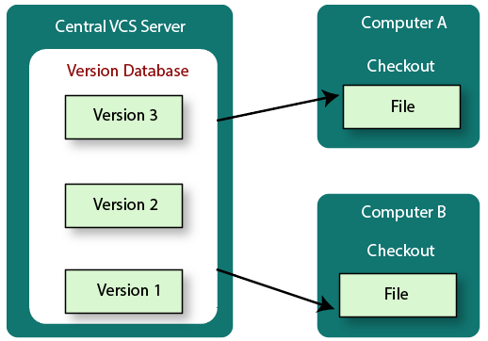

These systems have a single server that contains the versioned files, and some clients to check out files from a central place.

Centralized version control systems have many benefits, especially over local VCSs.

* Everyone on the system has information about the work what others are doing on the project.
* Administrators have control over other developers.
* It is easier to deal with a centralized version control system than a localized version control system.
* A local version control system facilitates with a server software component which stores and manages the different versions of the files.

It also has the same drawback as in local version control system that it also has a single point of failure.

### **Distributed Version Control System**

Centralized Version Control System uses a central server to store all the database and team collaboration. But due to single point failure, which means the failure of the central server, developers do not prefer it. Next, the Distributed Version Control System is developed.

In a Distributed Version Control System (such as Git, Mercurial, Bazaar or Darcs), the user has a local copy of a repository. So, the clients don't just check out the latest snapshot of the files even they can fully mirror the repository. The local repository contains all the files and metadata present in the main repository.

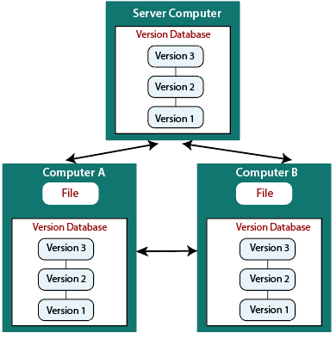

DVCS allows automatic management branching and merging. It speeds up of most operations except pushing and pulling. DVCS enhances the ability to work offline and does not rely on a single location for backups. If any server stops and other systems were collaborating via it, then any of the client repositories could be restored by that server. Every checkout is a full backup of all the data.

These systems do not necessarily depend on a central server to store all the versions of a project file.

## Difference between Centralized Version Control System and Distributed Version Control System

Centralized Version Control Systems are systems that use **client/server** architecture. In a centralized Version Control System, one or more client systems are directly connected to a central server. Contrarily the Distributed Version Control Systems are systems that use **peer-to-peer** architecture.

There are many benefits and drawbacks of using both the version control systems. Let's have a look at some significant differences between Centralized and Distributed version control system.

|  |  |
| --- | --- |
| **Centralized Version Control System** | **Distributed Version Control System** |
| In CVCS, The repository is placed at one place and delivers information to many clients. | In DVCS, Every user has a local copy of the repository in place of the central repository on the server-side. |
| It is based on the client-server approach. | It is based on the client-server approach. |
| It is the most straightforward system based on the concept of the central repository. | It is flexible and has emerged with the concept that everyone has their repository. |
| In CVCS, the server provides the latest code to all the clients across the globe. | In DVCS, every user can check out the snapshot of the code, and they can fully mirror the central repository. |
| CVCS is easy to administrate and has additional control over users and access by its server from one place. | DVCS is fast comparing to CVCS as you don't have to interact with the central server for every command. |
| The popular tools of CVCS are **SVN** (Subversion) and **CVS**. | The popular tools of DVCS are **Git** and **Mercurial**. |
| CVCS is easy to understand for beginners. | DVCS has some complex process for beginners. |
| If the server fails, No system can access data from another system. | if any server fails and other systems were collaborating via it, that server can restore any of the client repositories |

# **How to Install Git on Windows**

To use Git, you have to install it on your computer. Even if you have already installed Git, it's probably a good idea to upgrade it to the latest version. You can either install it as a package or via another installer or download it from its official site.

Now the question arises that how to download the Git installer package. Below is the stepwise installation process that helps you to download and install the Git.

## How to download Git?

**Step1**

To download the Git installer, visit the Git's official site and go to download page. The link for the download page is <https://git-scm.com/downloads>. The page looks like as

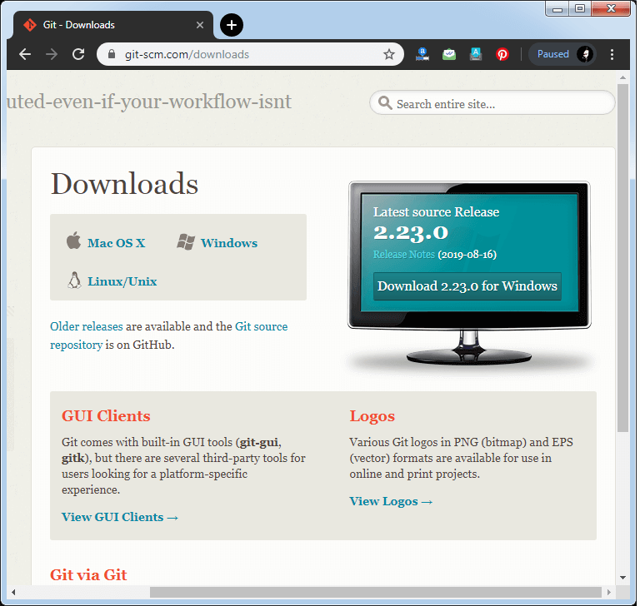

Click on the package given on the page as **download 2.23.0 for windows**. The download will start after selecting the package.

Now, the Git installer package has been downloaded.

## Install Git

**Step2**

Click on the downloaded installer file and select **yes** to continue. After the selecting **yes** the installation begins, and the screen will look like as

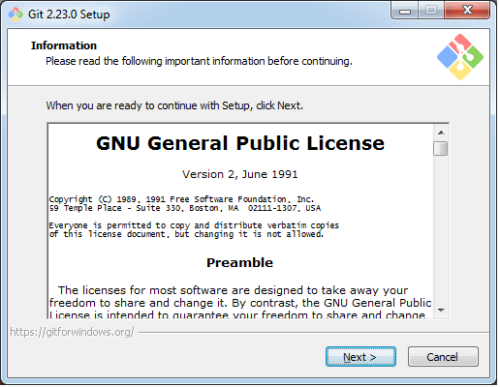

Click on **next** to continue.

**Step3**

Default components are automatically selected in this step. You can also choose your required part.

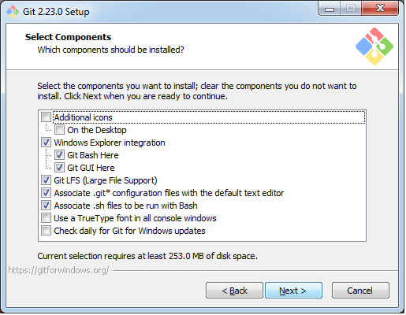

Click next to continue.

**Step4**

The default Git command-line options are selected automatically. You can choose your preferred choice. Click **next** to continue.

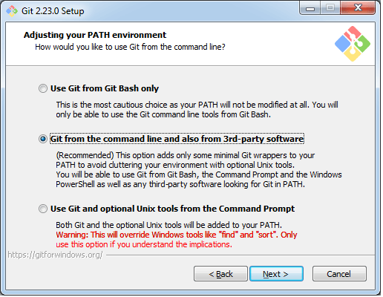

**Step5**

The default transport backend options are selected in this step. Click **next** to continue.

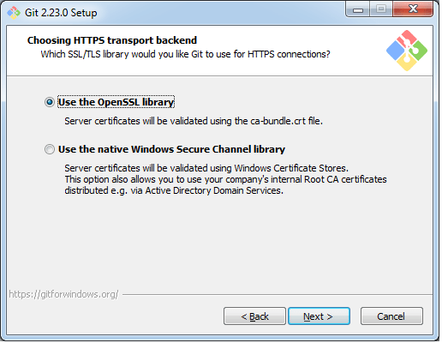

**Step6**

Select your required line ending option and click next to continue.

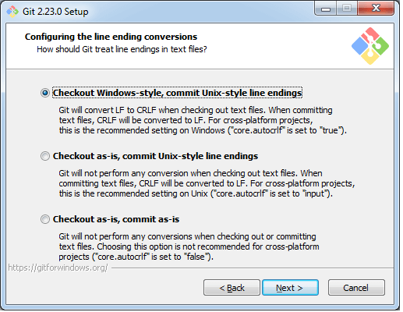

**Step7**

Select preferred terminal emulator clicks on the **next** to continue.

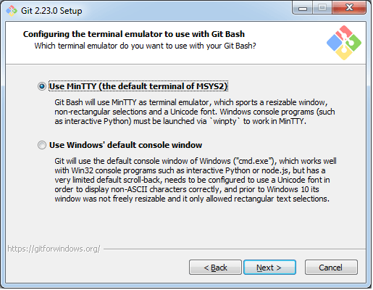

**Step8**

This is the last step that provides some extra features like system caching, credential management and symbolic link. Select the required features and click on the **next** option.

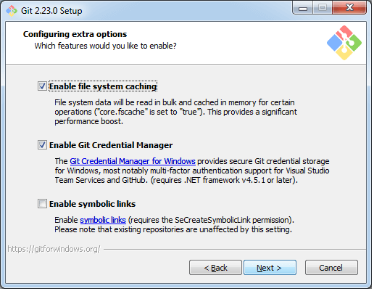

**Step9**

The files are being extracted in this step.

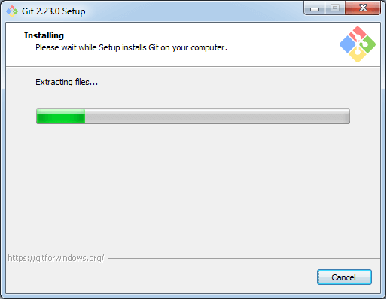

Therefore, The Git installation is completed. Now you can access the **Git Gui** and **Git Bash**.

The **Git Gui** looks like as

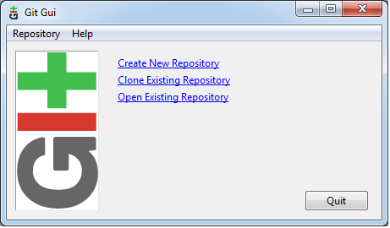

It facilitates with three features.

* Create New Repository
* Clone Existing Repository
* Open Existing Repository

The **Git Bash** looks like as

